PROJECT SUMMARY SHEET

AWARD FISCAL YEAR: 2021

PROJECT TITLE: **Riparian Buffer Initiative**

NAME: State of South Dakota ADDRESS: Joe Foss Building, 523 East Capitol

CITY: Pierre, SD ZIP CODE: 57501

PHONE: (605) 773-4351 FAX:

EMAIL: [Bill.Smith](mailto:rocky.knippling@sd.nacdnet.net)@state.sd.us PROJECT LOCATION: Statewide

WATERSHED NAME: Statewide PROJECT TYPES (See List): Watershed

HYRDOLOGIC UNIT CODE (HUC): All HIGH PRIORITY WATERSHED? Yes

POLLUTANT TYPE: Agriculture UWA CATEGORY: N/A

TMDL DEVELOPMENT (Y/N) N TMDL IMPLEMENTATION: (Y/N) Y

TMDL PRIORITY (High, Medium, Low): High WATERBODY TYPES: Lakes, rivers, streams

ECOREGION: Statewide

PROJECT CATEGORY: Implementation

GROUNDWATER PROJECT? No

**DANR Match: $3,505,000 RBI Match Partners: $500,000**

**DANR Non-Match: $625,000 RBI Non-Match Partners: $625,000**

**Total Project Cost: $5,255,000**

**Funded Full Time Personnel: 1.0**

**GOALS**: The goal of the Riparian Buffer Initiative is to restore or protect the riparian buffers along streams across the State of South Dakota. Watershed implementation projects install buffers to trap sediment, reduce erosion, sequester carbon and reduce nutrient loading along rivers and streams with great success. Chronic bank wasting and cropland erosion are major sources of sediment in surface waters. Excess nutrients cause harmful algal blooms and excessive aquatic plant growth. The use of riparian buffers with alternate water sources and fencing will allow those areas to function as a filter for overland runoff, while providing high quality water to livestock.

**PROJECT DESCRIPTION**: Nonpoint source pollution can be difficult to control, measure, and monitor, and has a major effect on our rivers and streams. In South Dakota, common pollutants include sediments, nitrogen, phosphorus, and bacteria. These contaminants reach our surface waters through runoff and erosion. Riparian buffers are an effective way to filter out pollutants by slowing down runoff and allowing sediments to filter out. Buffers also allow nutrients to be taken up by plant tissues before entering waterbodies.

Through the South Dakota Riparian Buffer Initiative, we have identified streams that are degraded and critically important to the state and our residents which need additional resources to foster greater enrollment in conservation practices to reduce nonpoint source pollution.

Producers that enroll in the initiative will be required to buffer either existing pastureland or revegetate cropland. Enrollment requires a buffer of at minimum 50 ft and not to exceed 120 ft. Vegetation may not be harvested or mowed between May 1 and August 1. Vegetation may not be grazed between May 1 and September 30. A minimum of four inches of cover must always be maintained.

1. **STATEMENT OF NEED**

**2.1** Nonpoint source pollution is a topic of much discussion within South Dakota, centered around ways to address it while working in harmony with our working lands way of life. In South Dakota, the primary pollutants are sedimentation, nitrogen, phosphorus, and bacteria (E. coli) which primarily reach our waters through surface runoff and erosion. Buffers are very effective in reducing nonpoint source pollution but getting producer buy in at a significant level, without turning to regulation, has proven to be challenging.

Current efforts have comprised of both federal and state level approaches with varying degrees of success and shortfalls. With federal programs, producers have been slow to utilize programs such as the Environmental Quality Incentive Program (EQIP) and the Conservation Stewardship Program (CSP) due to the lack of a rental payment to help with the reduction of income associated with enrollment in these programs. The Conservation Reserve Program (CRP) on the other hand provides the needed payment but severely reduces the producer’s ability to utilize the land in a conservation manner. On the state side, landowners can receive a reduction of 50% on their property taxes when they remove livestock from a buffer or provide a vegetated buffer in cropland. To date, this approach has received little attention primarily due to administrative and financial hurdles as the reduction is not at an amount high enough for producers to justify the loss of income potential.

**Table 1: Beneficial Uses for Eligible Water Bodies.**

| **Water Body** | **From** | **To** | **Beneficial Uses** | **County** |
| --- | --- | --- | --- | --- |
| Big Sioux River | Missouri River | Sioux Falls Diversion Ditch | 5,7,8 | Minnehaha |
| Big Sioux River | Sioux Falls Diversion Ditch | S2, T104N, R49W of the fifth principal meridian | 1,5,7,8 | Minnehaha |
| Big Sioux River | S2, T104N, R49W | Brookings-Moody County Line | 1,5,8 | Brookings/Moody |
| Big Sioux River | Brookings-Moody County Line | Lake Kampeska | 5,8 | Codington |
| Big Sioux River | Lake Kampeska | S28, T121N, R52W | 5,8 | Grant |
| Big Sioux River | S28, T121N, R52W | S32, T122N, R51W |  | Roberts |
| Bachelor Creek | Big Sioux River | S28, T106N, R50W | 6,8 | Moody |
| Battle Creek | Big Sioux River | S16, T107N, R52W | 6,8 | Lake |
| Beaver Creek (Lincoln County) | Big Sioux River | S9, T98N, R49W | 6,8 | Lincoln |
| Beaver Creek (Minnehaha County) | Split Rock Creek | South Dakota - Minnesota border | 6,8 | Minnehaha |
| Four Mile Creek | Beaver Creek (Minnehaha County) | South Dakota - Minnesota border | 6,8 | Minnehaha |
| Springwater Creek | Beaver Creek (Minnehaha County) | South Dakota - Minnesota border | 6,8 | Minnehaha |
| Big Ditch Creek | Big Sioux River | S1,T91N, R50W | 5,8 | Union |
| Big Ditch Creek | S1,T91, R50W | S21, T92N, R50W | 6,8 | Union |
| Brule Creek | Big Sioux River | confluence of its east and west forks | 6,8 | Union |
| East Brule Creek | confluence with Brule Creek | S3, T95N, R49W | 6,8 | Union |
| Flandreau Creek | Big Sioux River | Minnesota Border | 6,8 | Moody |
| Hidewood Creek | Big Sioux River | U.S. Highway 15 | 6,8 | Deuel |
| Medary Creek | Big Sioux River | South Dakota - Minnesota border | 6,8 | Brookings |
| Deer Creek | Medary Creek | S30, T111N, R47W | 6,8 | Brookings |
| Nine Mile Creek | Big Sioux River | Lake Alvin | 6,8 | Lincoln |
| No Name Creek, also known as Brookfield Creek, (Brookings and Moody Counties) | Big Sioux River | S22, T104N, R48W | 6,8 | Brookings |
| Owens Creek | Blue Dog Lake | S17, T122N, R52W | 4,8 | Roberts |
| Pattee Creek | Big Sioux River | Lake Lakota outlet | 5,8 | Lincoln |
| Peg Munky Run | Big Sioux River | S17, T113N, R50W | 6,8 | Deuel |
| Pickerel Creek (Day County) | Pickerel Lake | Waubay Lake | 6,8 | Day |
| Park Creek | Bourne Slough | Silver Creek | 6,8 | Lake |
| Silver Creek | Park Creek | Lake Herman | 6,8 | Lake |
| Six Mile Creek | North Deer Creek | S30, T112N, R48W | 6,8 | Brookings |
| College Creek | Big Sioux River | S12, T110N, R50W | 6,8 | Brookings |
| North Deer Creek | Big Sioux River | U.S. Highway 15 | 6,8 | Deuel |
| Skunk Creek | Big Sioux River | outlet of Brant Lake | 6,8 | Lake |
| Unnamed tributary Skunk Creek | Skunk Creek | S21, T102N, R51W | 6,8 | Minnehaha |
| Willow Creek | Skunk Creek | S16, T102N, R50W | 6,8 | Minnehaha |
| Split Rock Creek | Big Sioux River | Minnesota border | 5,7,8 | Minnehaha |
| West Pipestone Creek | Split Rock Creek | S33, T105N, R48W | 6,8 | Minnehaha |
| Unnamed tributary of West Pipestone Creek | West Pipestone Creek | Confluence with an unnamed tributary in S9, T103N, R48W | 5,8 | Minnehaha |
| Unnamed tributary | Unnamed tributary of West Pipestone Creek | EROS outfall in S8, T103N, R48W | 5,8 | Minnehaha |
| Slip-Up Creek | Big Sioux River | to its headwaters in S19, T104N, R48W | 6,8 | Minnehaha/Moody |
| Pipestone Creek | Split Rock Creek | Minnesota border | 5,7,8 | Minnehaha |
| Strayhorse Creek | Big Sioux River | S26, T116N, R51W | 6,8 | Codington |
| Spring Creek (Moody County) | Big Sioux River | S22, T109, R47W | 6,8 | Brookings |
| Jack Moore Creek | Big Sioux River | S33, T107N, R49W | 6,8 | Moody |
| Union Creek | Big Sioux River | confluence with East and West Forks | 6,8 | Union |
| Indian River | Big Sioux River | U.S. Highway 81 | 6,8 | Grant |
| Willow Creek | Big Sioux River | S7, T117N, R50W | 6,8 | Deuel |
| Big Sioux River | S28, T121N, R52W | Grant-Roberts County Line | N/A | Added by Grant County Commission |
| Indian River | U.S. Highway 81 | S35, T121N, R51W | N/A | Added by Grant County Commission |
| Unnamed Tributary of Indian River | S11, T120N, R52W | S12, T120N, R52W | N/A | Added by Grant County Commission |
| Soo Creek | Big Sioux River | Codington-Grant County Line | N/A | Added by Codington County Commission |
| Mahoney Creek | Big Sioux River | S33, T119N, R52W | N/A | Added by Codington County Commission |
| Mud Creek | Big Sioux River | S5, T118N, R51W | N/A | Added by Codington County Commission |
| Unnamed Tributary of Mud Creek | Mud Creek | S1, T117N, R52W | N/A | Added by Codington County Commission |
| Strayhorse Creek | S26, T116N, R51W | Codington-Deuel County Line | N/A | Added by Codington County Commission |
| Unnamed Tributary of Big Sioux River | Big Sioux River | Lake Poinsett Outlet | N/A | Added by Hamlin County Commission |
| Dolph Creek | Lake Norden | S6, T113N, R52W | N/A | Added by Hamlin County Commission |

Numerical Key to Beneficial Uses listed in Table 1:

(1) Domestic water supply waters;

(2) Coldwater permanent fish life;

(3) Coldwater marginal fish life;

(4) Warmwater permanent fish life;

(5) Warmwater semipermanent fish life;

(6) Warmwater marginal fish life:

(7) Immersion Recreation;

(8) Limited contact recreation waters;

(9) Fish and wildlife propagation, recreation, and stock watering waters;

(10) Irrigation;

(11) Commerce and industry

**2.3 Maps**

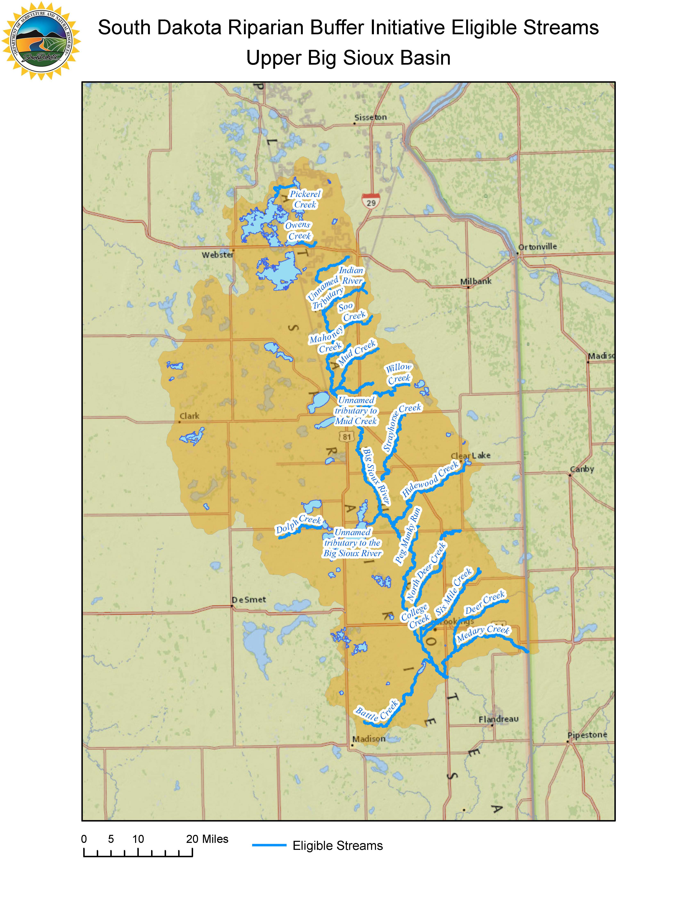

**Figure 5: Eligible Streams in the Upper Big Sioux River Basin.**

**Figure 6: Eligible Streams in the Lower Big Sioux River Basin.**

**3.0 Project Description**

**3.1 Project Goal**

The goal of the Riparian Buffer Initiative is to restore or protect riparian buffers along streams across the State of South Dakota. Our watershed implementation projects install buffers to trap sediment, reduce erosion, and reduce nutrient loading along rivers and streams with great success. Chronic bank wasting and cropland erosion are major sources of sediment in our surface waters. Excess nutrients cause harmful algal blooms and excessive aquatic plant growth. The use of riparian buffers with alternate water sources and fencing will allow for those areas to function as a filter for overland runoff, while providing high quality water to livestock.

**Project Objectives, Tasks, Products, Milestones, and Responsible Agencies:**

**Objective 1:** **Reduce bacteria (E. coli) and sediment loadings in South Dakota watersheds through limiting access of livestock to waterbodies.**

**Task 1: Riparian Buffers.** Provide resources to livestock owners to better manage, limit or prevent access to water bodies to reduce direct pollutant loading.

Riparian buffers will be implemented on 3,800 acres of croplands and marginal pasture lands. Enrollment of land immediately adjacent to the waterbody (bankfull or average high-water mark), with a minimum buffer distance of 50 feet and maximum distance of 120 feet is eligible for the program. Best Management Practices (BMPs) will be implemented targeting critical riparian areas that have been, or have the potential to be, significant sources of bacteria (E. coli) contamination and total suspended solids (TSS) loadings due to degradation of riparian areas from continuous grazing or poor farming practices.

Eligible stream segment payments will equal 100 percent of the CRP rate for cropland or pastureland for 10 years. In addition, participants with pastureland along eligible stream segments are eligible for exclusion fencing and alternative water cost share. Exclusion fencing and alternative water will be cost-shared at 75% up to $5,000 per contract within the RBI project. Additional cost share may be available to participants within Section 319 funded project areas. Mowing and chemical applications will be used for weed control. Weed control will be utilized if needed to establish a functioning grass buffer. Areas needed to be seeded to grass will be done so following NRCS guidelines.

Where possible DANR will use survey grade GPS to capture enrolled acres to assist in verification. Alternatively, ArcGIS will be used to determine acres enrolled.

Minimum program requirements:

* Land must be within one hundred twenty feet of a waterbody noted in ARSD 74:51:03 or must be locally designated by the local board of county commissioners as outlined in SDCL 10-6-31.7
* Land must have existing or planted perennial vegetation
* Vegetation may not be harvested or mowed between May 1 – August 1
* Vegetation may not be grazed between May 1 – Sept. 30
* A minimum of four inches of cover must always be maintained
* Buffers must be a minimum of fifty feet and cannot exceed 120 feet in width
* Must commit to a ten-year contract

**Products:** Implement 3,800 acres of riparian buffers, 820,216 linear feet of fence, 250 new water developments, 3,800 acres of weed control, 400 acres of grass seeding. BMP’s will be implemented with funding from DANR and GFP.

**Milestones:** Riparian buffer – 3,800 acres

Fencing – 820,216 linear feet

Water Developments - 250 new alternative water source developments

Weed control – 3,800 acres

Grass seeding – 400 acres

**Total Cost: $4,005,000 RBI Partners Funding: $4,005,000**

**Responsible Agencies:**

**South Dakota Department of Agriculture & Natural Resources**

**South Dakota Department of Game, Fish & Parks**

**Pheasants Forever**

**Objective 2 Personnel and Administration**

**Task 2: Project Support.** Multiple agencies will work together across the State to complete the RBI.

Various partners that are included in the RBI have full time staff that are located within local NRCS service centers. These staff will play a crucial role in promoting RBI with landowners and identifying participants. Employees of water development districts, conservation districts, Pheasants Forever Farm Bill Biologists, and Game Fish, and Parks private lands biologists work with local landowners and producers on a daily basis. Their existing working relationships with landowners throughout the Big Sioux River Basin on other conservation projects will help promote RBI.

Pheasants Forever will be responsible for contacting and informing the public about the Riparian Buffer Initiative through news articles, social media, and producer visits. Once landowners have agreed to participate in the program, Pheasants Forever Farm Bill Biologists will be available to work with them to provide all the technical assistance necessary. Technical assistance includes contracting, boundary flagging, and grass seeding. DANR staff will work with Pheasants Forever to ensure accuracy of proposed property and entering contract information along with pollutant load reduction estimates into the DANR Tracker database for requesting funding. DANR will in turn provide to the landowners. Annual spot checks will be conducted on all practices implemented through all partnering agencies working together and spot check information will be sent to the RBI Coordinator.

Number of staff involved with the RBI from partners:

* DANR- 4
* Pheasants Forever- 13
* GF&P- 6
* James River WDD- 3
* East Dakota WDD- 2

**Milestones:** Final Report

**Total Cost: $750,000 RBI Partners Funding: $750,000**

**Responsible Agencies:**

**South Dakota Department of Agriculture & Natural Resources**

**South Dakota Department of Game, Fish & Parks**

**Pheasants Forever**

**3.3 Milestone Table (See Page 14)**

**3.4 Required Permits**

All required permits will be obtained for installation of BMPs during this proposed project. If any historical findings are made, the State Historic Preservation Office (SHPO) will be contacted.

* Historical Preservation compliance will be adhered to for any BMPs involving ground disturbing activities.
* Compliance to meet requirements of the Threatened and Endangered Species Act.

**3.5 Project Sponsor**

The Department of Agriculture and Natural Resources is the project sponsor.

**3.6 Operation and Maintenance Responsibilities**

Operation and Maintenance (O&M) responsibilities for BMPs funded by the RBI project will be detailed in contracts entered in between the Department of Agriculture and Natural Resources and landowners installing BMPs. Contracts for BMP installation will specify BMP O&M needs, procedures for BMP failure or abandonment, and the life span BMPs will be maintained. The Department of Agriculture and Natural Resources will be responsible for completing operation and maintenance contracts. Pheasants Forever will be responsible for on-site evaluation of BMPs installed to ensure operation and maintenance is being completed, and follow-up as needed to ensure BMP operation for its designated life span.

**4.0 COORDINATION PLAN**

* + The lead sponsor is the Department of Agriculture and Natural Resources, Pierre, South Dakota. The Department of Agriculture and Natural Resources along with Pheasants Forever will be responsible for completion of project goals, objectives, tasks, and completion of cash and in-kind match documentation. Department of Agriculture and Natural Resources will partner with local, state, and interested organizations and agencies to implement this project utilizing their available technical and financial assistance as follows:
* Pheasants Forever: Pheasants Forever Farm Bill Biologists will plan BMPs such as fencing, water developments, and grass plantings.
* SD Game, Fish and Parks: The SD GF&P will provide $500,000 in financial assistance and contact producers about RBI.
* Section 319 Implementation Projects: Upper Big Sioux, Big Sioux, South Central, and Belle Fourche will provide technical assistance as needed and financial assistance where possible. These projects will also make producer contacts for the RBI Project and may assist in contract development.
  1. **Local Support**

The Riparian Buffer Initiative will be an important economic and social asset across the state for rural residents and landowners. The RBI will work with local entities to get the project established. Many local entities have expressed great support for the RBI Project.

* 1. **Project Coordination**

The Riparian Buffer Initiative Project will be implemented through leadership by the Department of Agriculture and Natural Resources, with support from local, state, and federal partners (see Section 4.0) to maximize technical assistance and funding for successful project implementation. Various partners that are included in the RBI have full time staff that are located within local NRCS service centers. These staff will play a crucial role in promoting RBI with landowners and identifying participants. Employees of water development districts, conservation districts, Pheasants Forever Farm Bill Biologists, and Game Fish, and Parks private lands biologists work with local landowners and producers on a daily basis. Their existing working relationships with landowners throughout the Big Sioux River Basin on other conservation projects will help promote RBI. Once landowners have agreed to participate in the program, the Pheasants Forever Farm Bill Biologists will be available to work with them to provide all the technical assistance necessary.

* 1. **Coordination with Other Projects**

This project will be implemented through coordination and partnership with other organization programs to create complementary activities. Key activities by programs that are similar for this project are as follows:

* BMP implementation: The installation of BMPs on cropland and grassland in this proposal will request funding from South Dakota Department of Game, Fish & Parks.
* Technical assistance for BMP implementation will be provided through a coordinated effort to include delivery by Pheasants Forever Farm Bill Biologists, South Dakota Department of Game Fish, and Parks private lands biologists, watershed coordinators, and conservation districts.

**5.0 EVALUATION AND MONITORING**

**5.2 Indicators of Success**

The Department of Agriculture and Natural Resources will monitor project progress based on project milestones and water quality sampling.

The effectiveness of BMPs installed relative to the improvement in water quality will be evaluated using tools and models available such as:

1. Water sampling to monitor water quality changes.
2. Spreadsheet Tool for Estimating Pollutant Loads (STEPL) for estimating annual load reductions from BMP installation.

Water sampling, testing, and test result evaluations for water quality changes will be completed by SD DANR, East Dakota Water Development District, and South Central Implementation Project Staff. Sampling will be completed according to the “Standard Operating Procedures for Field Samplers, Volumes I & II, Tributary and In-Lake Sampling Techniques”, State of South Dakota, DENR, 2018.

Progress reporting to meet milestones will include a financial accounting of funds, and the source of funds for each milestone. Local support, partner in-kind, and cash contributions will be documented for BMP installation and project management activities.

**5.3 Recordkeeping and data storage and management**

The Department of Agriculture and Natural Resources will be responsible for processing, storing, and managing contracts during implementation of this project.

**5.4 STEPL to determine progress/success**

The Department of Agriculture and Natural Resources will utilize STEPL to assess project progress and success of BMP installation in the watersheds.

**5.5 Operation and Maintenance**

The installation of BMPs for this project (riparian buffers, fencing, water development, etc.) will involve a contract between the Department of Agriculture and Natural Resources and the landowner, for operation and maintenance of the BMP to be installed. The operation and maintenance section of the contract will specify the life span of the BMP, who is responsible for maintenance and operation, and normal operation and maintenance needs for each BMP.

Pheasants Forever will be responsible to ensure that the Operation and Maintenance contracts are implemented. The Department of Agriculture and Natural Resources and local partners, such as the project area Pheasants Forever Farm Bill Biologists, will lead efforts to implement needed operation and maintenance on BMPs after this project’s grant period.

**6.0 BUDGET (See Also Project Budget Page on 15)**

**BUDGET TABLE FOR RIPARIAN BUFFER INITIATIVE PROJECT 7/2021 – 7/2026**

|  |  |
| --- | --- |
| Funding Source | Total |
| **STATE/LOCAL MATCH (FA)**  1.) SD DANR BIG SIOUX (HB 1256)  2.) SD DANR  3.) SD GF&P  **Subtotals:** | $3,000,000  $505,000  $500,000  **$4,005,000** |
| **STATE/LOCAL NONMATCH (TA)**   1. PRODUCER   2.) SD DANR  3.) PHEASANTS FOREVER  **Subtotals:** | $500,000  $625,000  $125,000  **$950,000** |
| **TOTAL BUDGET** | **$5,255,000** |

**Key:**

FA Financial Assistance

TA Technical Assistance

GF&P SD Game, Fish and Parks Department

DANR SD Department of Agriculture and Natural Resources



